Project Risk Assessment and Method Statement

INSTRUCTIONS
This RAMS document is a downloadable template for initial completion by a representative of the organisation in receipt of the timeclock installations. These areas are indicated by “Org Input”. Once completed by the organisation’s representative, please send it as a word document to support@cubepurple.com where Cube Purple will complete the rest of the form (as indicated by “CP Input”). The completed document will then be sent to the organisation’s representative, and the Cube Purple installer will also have a physical copy of this while on site.

[DELETE THIS INSTRUCTIONS SECTION WHEN SENDING COMPLETED DOC TO ORGANISATION AND PRINTING FOR INSTALLER]

GENERAL DETAILS
Project Name: | ClockedIn Time & Attendance Device Installation | Project Ref: | CP Input
Contractor / Subcontractor: | Cube Purple Limited | Prepared by: | Jon House
Method Statement No. | CP-EP-10 | Revision No. | 3
Method Statement Title: | Timeclock Installation | Site Manager: | Org Input
Site Foreman/Supervisor: | Mark Shaw | H&S Representative: | Mark Shaw / Org Input
Site Address: | Org Input | Site Postcode: | Org Input

HIGH RISK WORKS

High Risk Activity (Y/N): | No
Recorded on High Risk Register (Y/N): | No
High Risk Workshop undertaken (Y/N + date): | No

DOCUMENT REVIEW

Reviewed by: |  |  | Signed: |  | Date: | Status:
Mark Shaw |  |  | Mark Shaw |  | 03/03/2023 | 1
Mark Shaw |  |  | Mark Shaw |  | 01/08/2024 | 2
 |  |  |  |  | 02/05/2025 | 3
 | SECTION 1: DESCRIPTION OF WORKS (Brief Summary)
 | Installation of Time and Attendance Android and Kiosk
 | Unit Type | Quantity |  | Power Supply
 | CP input – source from data gathering sheet | CP input – source from data gathering sheet |  | CP input – source from data gathering sheet

SECTION 2: KEY HAZARDS / RISKS (Refer to Risk Assessment/s)
Hazards/Risks | Key Controls
Electrical Connection via 3-pin plug or connection to a pre-installed Non-Switched Fused Spur | Trained Installer
Drill 4 x 6mm holes in wall for mounting kiosk to wall | Trained Installer
SECTION 3: SEQUENCE OF WORKS (Method)
[CP Input - remove below as applicable]
FP Unit:
- Arrive on-site and sign in as per site processes.
- Ensure location of installation is safe and ready for installation.
- Install angle bracket on wall by drilling 4 holes and affixing angle bracket to wall with 4 rawl plugs and 4 wall screws.
- Attach kiosk to angle bracket with 4 screws (included within the Kiosk).
- Connect 5 volt charger to power source via 3-pin 240v plug or connect to pre-installed Non-Switched Fused Spur.
- Place wire from power source to kiosk in pre-cut plastic conduit or trunking to secure wire.
- Place Android tablet into kiosk and plug in charger cable to the tablet.
- Place faceplate on to kiosk.
- Provide appropriate user training.
Pro Unit:
- Arrive on-site and sign in as per site processes.
- Ensure location of installation is safe and ready for installation.
- Attach Unit backplate to the lid of the wall mount box using the screws provided.
- Install wall mount box (without the lid) by drilling 4 holes and affixing to the wall using with 4 rawl plugs and 4 wall screws.
- Thread the power cable wire in and out of the holes within the wall box keeping the transformer within the box.
- Connect 5 volt charger to power source via 3-pin 240v plug or connect to pre-installed Non-Switched Fused Spur.
- Place wire from power source to kiosk in pre-cut plastic conduit or trunking to secure wire
- Connect power to the device and place on the backplate, securing it with the bottom screw.
- Provide user training.
FR Unit:
- Arrive on-site and sign in as per site processes.
- Ensure location of installation is safe and ready for installation.
- Install wall mount to the wall by drilling 4 holes and affixing to the wall with 4 rawl plugs and 4 wall screws.
- Connect 5 volt charger to power source via 3-pin 240v plug.
- Place wire from power source to kiosk in pre-cut plastic conduit or trunking to secure wire.
- Fix unit to the wall mount using the screws provided.
- Provide appropriate user training.

SECTION 4: SUPERVISOR / LABOUR
Name: | Installer | Sole Installer | Site Supervisor
Mark Shaw | 
Linas Jaubonis

For low risk projects, it is accepted that a sole installer is competent enough to carry out work without the site supervisor present.

SECTION 5: TEMPORARY WORKS (TW)
- No hot works required
- Total Installation time - around 30 -60 minutes per unit

SECTION 6: PLANT & EQUIPMENT
- Plant and Equipment required:
- Cordless Drill
- Electrical (include PAT):
Not required as the protection of appliances marked with this double square symbol is ensured by double insulation and does not require a safety connection to electrical earth or PAT testing

- Tools:
Drill
Crosshead screwdriver – Medium
Electricians Flat-head screwdriver – Small
Small wire cutters
Junior Hacksaw
- Other:
N/A

SECTION 7: MATERIALS
Please comment “Yes / No” under the pictograms below
  Acute Toxicity  Y/N: No |   Explosive  Y/N: No |   Oxidising  Y/N: No
  Flammable  Y/N: No | 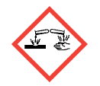  Corrosive  Y/N: No |   Gas Under Pressure  Y/N: No
  Serious Health Hazard  Y/N: No |   Health Hazard  Y/N: No |   Hazardous to the Environment  Y/N: No

Materials required:  4 x Rawl Plugs  4 x Screws | Storage:  Not Required | Hazardous Substances/SDS:  None | Waste Management:  N/A

SECTION 8: PPE
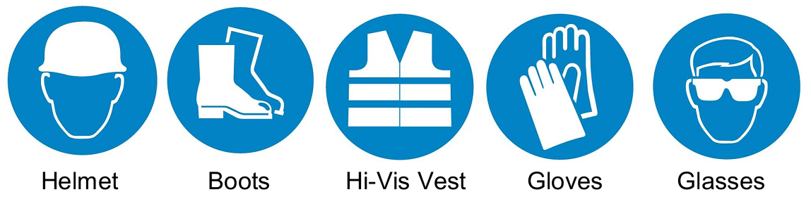
Please insert Y/N in box below
No | No | Yes | No | No
Other: e.g. Respiratory, Hearing protection etc. N/A

SECTION 9: PERMITS
 | Yes | No | Comments
Hotworks:
Excavations:
Roofworks:
Temporary works
Confined Spaces:
Live Services:
Risers/Shafts:
Ladder:
Works in ESB Hazard Zone:
Other: |  | N/A

SECTION 10: THIRD PARTY CO-ORDINATION
- None required – all prerequisite work should be completed before Cube Purple’s Installation visit. This includes power and network connectivity.

SECTION 11: RISK ASSESMENT
Activity | Installation of Time & Attendance Device
Description | Installation of Time and Attendance device
Work Start Date | CP Input
Duration | 30-60 minutes per unit
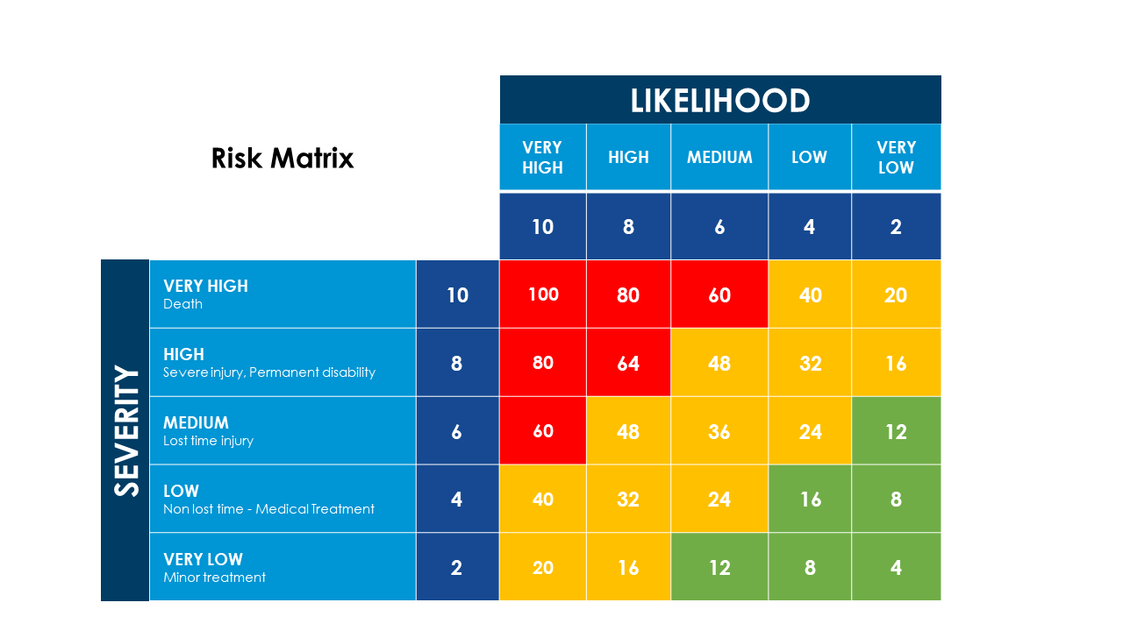

Further Assessments required?
☐ | Health Surveillance
☐ | COSHH
☐ | Manual Handling
☐ | DSE
☐ | Other (please specify

Hazards Identified | Who might be harmed & how | Risk Severity | Risk Likelihood | Risk Score | Current Control Measures | Improvement Actions
Drill 4 holes in designated wall | Installer – Drill bit could slip during operation | 2 | 2 | 4 | Trained Installer | None
Connect unit to power supply via 3-pin plug or Non-Switch Fused Spur | Installer - Electrocution | 4 | 2 | 8 | Trained Installer | None

I, [CP Input – Installer Name], confirm that I have read and understood this Risk Assessment and Method Statement, and by signing below, I acknowledge my agreement and acceptance.

Name | CP Input
Position | CP Input
Signature | CP Input
Date | CP Input

